**User:**

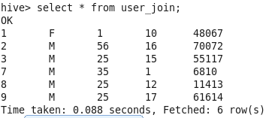

**Rating:**

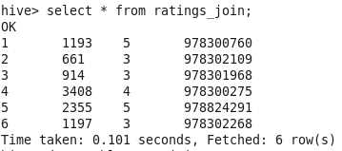

**Movies:**

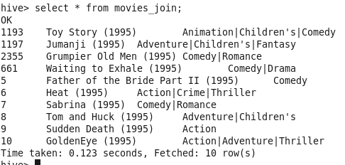

**FULL OUTER JOIN:(Und the position of null)**

Common rows that are present in both tables will be returned once based on matching condition. All other records from both the tables will be returned with Null values. While displaying output, query will be analyzed left to right and displays rows in left table first.

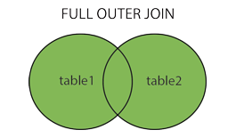

**Full-Outer-Join without where:**

select * from user_join u FULL OUTER JOIN ratings_join r on u.userid = r.userid;

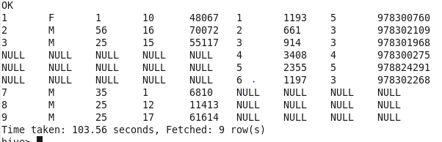

select * from ratings_join u FULL OUTER JOIN user_join r on u.userid = r.userid;

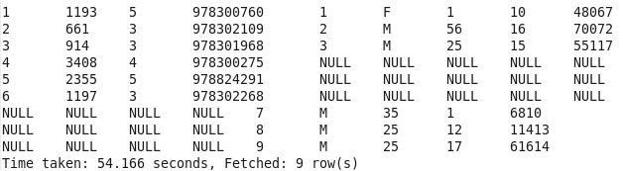

**user-Join1:**

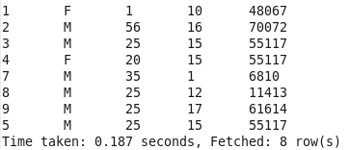

**rating_join1:**

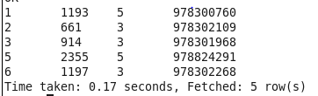

**Outer-Join Precedence Example:**

select * from user_join1 u FULL OUTER JOIN ratings_join1 r on u.userid = r.userid; 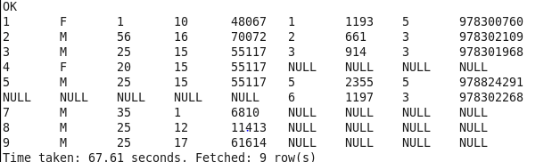

In precedence, the key that is placed in "ON" clause from the left table is considered first and checked with other table. If a match is found in the other table the entire column is returned after joining.

**After deleteing ID 1 from user_join1:**

select * from user_join1 u FULL OUTER JOIN ratings_join1 r on u.userid = r.userid;

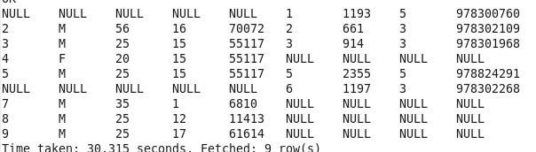

**Changing the position of table name:**

select * from ratings_join1 u FULL OUTER JOIN user_join1 r on u.userid = r.userid;

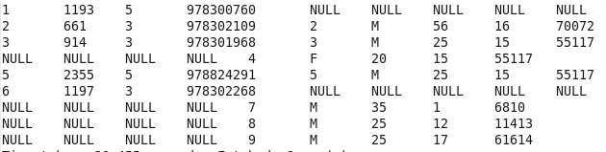

**Using AND inside ON clause:**

Null is display below ID 1 and 2 because it matches one condition **"u.userid = r.userid"** in AND clause.

select * from user_join1 u FULL OUTER JOIN ratings_join1 r on ( u.userid = r.userid AND u.userid = r.rating );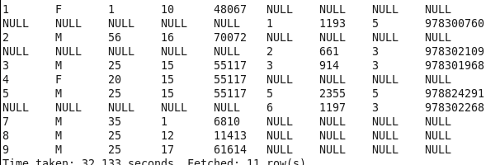

**Full-Outer-Join without where:**

select u.userid,u.Gender,u.age,r.movieid, r.rating,r.timestamp_rating from user_join u FULL OUTER JOIN ratings_join r on u.userid = r.userid;

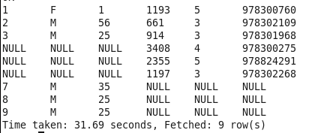

**FULL OUTER JOIN with ON and Where:**

select u.userid,u.Gender,u.age,r.movieid, r.rating,r.timestamp_rating from user_join u FULL OUTER JOIN ratings_join r on u.userid = r.userid where u.userid = 1;

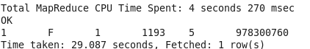

**Full Outer Join with ON and SORT-BY:**

select u.userid,u.Gender,u.age,r.movieid, r.rating,r.timestamp_rating from user_join u FULL OUTER JOIN ratings_join r on u.userid = r.userid SORT BY u.userid;

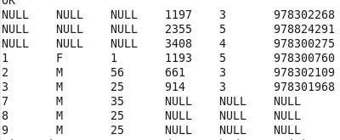

**Full outer Join - ON, Sort BY dual Column:**

select u.userid as uid,u.Gender as gen, u.age,r.movieid, r.rating, r.timestamp_rating from user_join u FULL OUTER JOIN ratings_join r on u.userid = r.userid SORT BY gen,u.age;

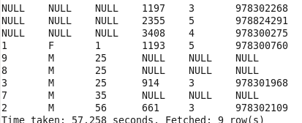

**Full Outer Join - ON, Order By:**

select u.userid,u.Gender,u.age,r.movieid, r.rating,r.timestamp_rating from user_join u FULL OUTER JOIN ratings_join r on u.userid = r.userid ORDER BY u.userid;

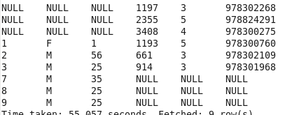

**Full Outer Join - ON, Order By:**

select u.userid,u.Gender,u.age,r.movieid, r.rating ,r.timestamp_rating from user_join u FULL OUTER JOIN ratings_join r on ( u.userid = r.userid AND u.userid = r.rating ) ORDER BY u.userid;

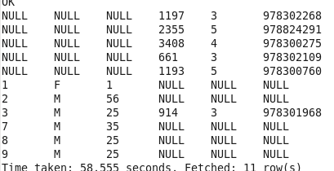  
**Full Outer Join - ON:**

The rows that satisfies single condition in "ON" clause appear first while displaying with NULL first (second and fourth row in the output below)

select u.userid,u.Gender,u.age,r.movieid, r.rating ,r.timestamp_rating from user_join u FULL OUTER JOIN ratings_join r on ( u.userid = r.userid AND u.userid = r.rating );

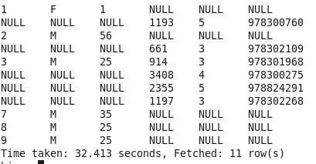

**Two FULL OUTER JOIN clause which joins all three table:(Not Understood)**

select u.userid,u.Gender,u.age,r.movieid, r.rating, r.timestamp_rating, m.title, m.genres from user_join u FULL OUTER JOIN ratings_join r on u.userid = r.userid FULL OUTER JOIN movies_join m on r.movieid = m.movieid ORDER BY u.userid,m.genres,r.movieid;

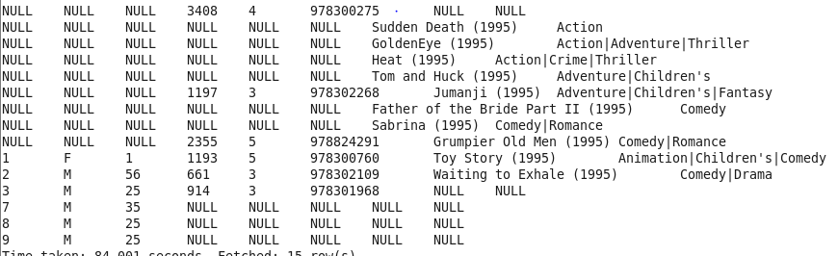

**Illegal:**

select u.userid as uid,u.Gender,u.age,r.movieid, r.rating,r.timestamp_rating from user_join u FULL OUTER JOIN ratings_join r on u.userid <= r.userid;

**#Invalid:** primarily because it is difficult to implement these kinds of joins in MapReduce. It turns out that Pig offers a cross product feature that makes it possible to implement this join, even though Pig’s native join feature doesn’t support it, either.

select u.userid,u.Gender,u.age,r.movieid, r.rating,r.timestamp_rating from user_join u FULL OUTER JOIN ratings_join r on ( u.userid = r.userid OR u.userid = r.userid ) ORDER BY u.userid;

Hive does not currently support using OR between predicates in ON clauses.

select u.userid,u.Gender,u.age,r.movieid, r.rating,r.timestamp_rating from user_join u FULL OUTER JOIN ratings_join r on u.userid = r.userid Group BY u.userid;

#GroupBY is not working here because no aggregate function is used.